SIMATS ENGINEERING
CO2- ASSESSMENT TOOL 2
Technical Presentation
COURSE NAME: ANALOG AND DIGITAL COMMUNICATION COURSE CODE: ECA0836
COURSE OUTCOME COVERED
CO 2: Explore angle modulation concepts including FM and PM, transmission bandwidth, noise sources and performance characterization, SNR calculations for AM and DSB‑SC systems, techniques for noise improvement with pre‑emphasis and de‑emphasis, and MATLAB‑based noise analysis for broadcast applications.
(Bloom Level mapped-BL3, BL4)
Assessment Tool Weightage: 35%
Duration: 5 min each student Marks:10
Each student will be assigned one topic for a classroom presentation. Students are required to present the topic clearly and concisely within the allotted time.
Dr.
QUESTIONS: Total Marks:

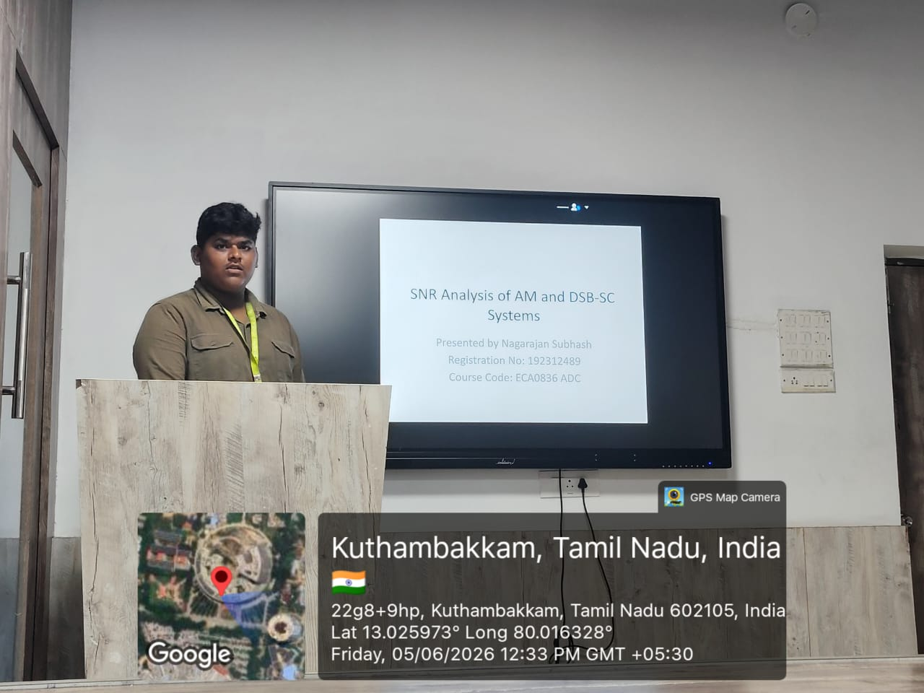
Code of Conduct:
I ____________________ (Name / Reg No) certify that this submission is my original work and that I have adhered to the guidelines specified for this assessment. I understand that any violation of academic integrity rules will result in disciplinary action.
Signature of the student: RUBRICS FOR CALCULATION:

Technical Presentation
Criteria | Weightage | Level 4 –  Exemplary | Level 3 – Proficient | Level 2 –  Developing | Level 1 –  Beginning
Technical  Content  Accuracy | 30 | Highly accurate, in-depth, and insightful technical explanation | Technically correct content  with adequate depth and clarity | Basic concepts presented with  limited accuracy and depth | Content contains major technical  errors; concepts poorly understood
Problem  Identification | 25 | Problem rigorously  analyzed using  appropriate and advanced methods | Problem clearly defined with a logical  engineering approach | Problem  identified but analysis or  methodology is weak | Problem statement  unclear or  incorrect; no logical approach
Use of Tools | 20 | Advanced tools, well-analyzed  data, and highly effective visuals | Appropriate tools and data  used effectively with clear  visuals | Limited use of tools and basic data  interpretation | Minimal or incorrect use of  tools and data;  poor visuals
Communication | 15 | Highly engaging, confident, and audiencefocused delivery | Clear, organized, and professional communication | Understandable but lacks clarity, structure, or confidence | Poor organization,  unclear speech, ineffective slides
Professionalism | 10 | Exemplary professionalism,  leadership, and ethical  awareness | Professional conduct with  effective team collaboration | Basic professionalism;  uneven team participation | Lacks professionalism; minimal  contribution or ethical  awareness

